**Online Shopping for Gadgets**

**Domain Description**

In today's tech-driven world, gadgets have become an integral part of daily life. Gadgets could encompass various items like smartphones, laptops, tablets, smartwatches, etc. The system will include functionalities for users to browse, search, purchase, and manage orders of these gadgets.

**Tables Before Normalization**

User Table

|  |  |  |  |  |  |  |  |
| --- | --- | --- | --- | --- | --- | --- | --- |
| **UserID** | **Username** | **Email** | **Password** | **Address** | **Phone** | **OrderID** | **ProductID** |
| 1 | JohnDoe | john@example.com | hashed123 | 123 Main St | 555-1234 | 101 | 01 |
| 2 | JaneSmith | jane@example.com | qwerty456 | 456 Elm St | 555-5678 | 102 | 02 |

Products Table

|  |  |  |  |  |  |  |  |
| --- | --- | --- | --- | --- | --- | --- | --- |
| **ProductID** | **ProductName** | **Description** | **Price** | **QuantityAvailable** | **UserID** | **CategoryID** | **CategoryName** |
| 01 | Smartphone Model X | Description of Model X | 599.99 | 100 | 1 | 001 | Smartphone |
| 02 | Laptop Model Pro | Description of Laptop | 899.99 | 50 | 1 | 002 | Laptop |
| 03 | Tablet Model Mini | Description of Tablet | 349.99 | 75 | 2 | 003 | Tablet |

Orders Table

|  |  |  |  |  |  |
| --- | --- | --- | --- | --- | --- |
| **OrderID** | **UserID** | **OrderDate** | **TotalAmount** | **ShippingAddress** | **Status** |
| 101 | 1 | 2023-12-01 08:00 | 1499.97 | 123 Main St | Shipped |
| 102 | 2 | 2023-12-02 10:30 | 1049.98 | 456 Elm St | Delivered |

OrderDetails

|  |  |  |  |  |
| --- | --- | --- | --- | --- |
| **OrderDetailID** | **OrderID** | **ProductID** | **Quantity** | **TotalAmount** |
| 201 | 101 | 01 | 2 | 1199.98 |
| 202 | 101 | 02 | 1 | 899.99 |
| 203 | 102 | 03 | 3 | 1049.97 |

**Normalization**

First Normal Form (1NF): Ensure atomic values in each cell and unique column names.

Second Normal Form (2NF): Remove partial dependencies.

Third Normal Form (3NF): Eliminate transitive dependencies.

There are redundant fields such as ProductName, Description, Price, Quantity present in multiple tables, leading to data duplication.

There's a lack of proper separation of concerns, causing dependencies that could lead to data inconsistencies.

Composite fields like OrderID, ProductID, and UserID appearing in multiple tables without normalized relations.

**Tables After Normalization**

User Table

|  |  |  |  |  |  |
| --- | --- | --- | --- | --- | --- |
| **UserID** | **Username** | **Email** | **Password** | **Address** | **Phone** |
| 1 | JohnDoe | john@example.com | hashed123 | 123 Main St | 555-1234 |
| 2 | JaneSmith | jane@example.com | qwerty456 | 456 Elm St | 555-5678 |

Products Table

|  |  |  |  |  |  |
| --- | --- | --- | --- | --- | --- |
| **ProductID** | **ProductName** | **Description** | **Price** | **QuantityAvailable** | **CategoryID** |
| 01 | Smartphone Model X | Description of Model X | 599.99 | 100 | 001 |
| 02 | Laptop Model Pro | Description of Model Pro | 899.9 | 50 | 002 |
| 03 | Tablet Model Mini | Description of Model Mini | 349.9 | 75 | 003 |

Category Table

|  |  |  |
| --- | --- | --- |
| **CategoryID** | **CategoryName** | **Description** |
| 001 | Smartphone | Smartphone description |
| 002 | Laptop | Laptop description |
| 003 | Tablet | Tablet description |

Orders Table

|  |  |  |  |  |  |
| --- | --- | --- | --- | --- | --- |
| **OrderID** | **UserID** | **OrderDate** | **TotalAmount** | **ShippingAddress** | **Status** |
| 101 | 1 | 2023-12-01 08:00 | 2099.97 | 123 Main St | Shipped |
| 102 | 2 | 2023-12-02 10:30 | 1049.98 | 456 Elm St | Delivered |

OrderDetails Table

|  |  |  |  |  |
| --- | --- | --- | --- | --- |
| **OrderDetailID** | **OrderID** | **ProductID** | **Quantity** | **Subtotal** |
| 201 | 101 | 01 | 2 | 1199.98 |
| 202 | 101 | 02 | 1 | 899.99 |
| 203 | 102 | 03 | 3 | 1049.97 |

The tables have atomic values. So, 1 NF

There are no partial dependencies in the tables. So, 2 NF

Third normal form is maintained as there are no transitive dependencies. So, 3 NF

**Table Description**

Users

|  |  |  |
| --- | --- | --- |
| **Attributes** | **Datatype** | **Constraints** |
| UserID | Integer | Primary Key |
| Username | String | Not Null |
| Email | String | Not Null |
| Password | String | Not Null |
| Address | String | Not Null |
| Phone | String | Not Null |

**Products**

|  |  |  |
| --- | --- | --- |
| **Attributes** | **Datatype** | **Constraints** |
| ProductID | Integer | Primary Key |
| ProductName | String | Not Null |
| Description | Text | Not Null |
| Price | Decimal | Not Null |
| QuantityAvailable | Integer | Not Null |
| CategoryID | Integer | Foreign key |

Categories

|  |  |  |
| --- | --- | --- |
| **Attributes** | **Datatype** | **Constraints** |
| CategoryID | Integer | Primary Key |
| CategoryName | String | Not Null |
| Description | Text | Not Null |

Orders

|  |  |  |
| --- | --- | --- |
| **Attributes** | **Datatype** | **Constraints** |
| OrderID | Integer | Primary Key |
| UserID | Integer | Foreign Key |
| OrderDate | Date | Not Null |
| TotalAmount | Decimal | Not Null |
| ShippingAddress | String | Not Null |
| Status | String | Not Null |

OrderDetails

|  |  |  |
| --- | --- | --- |
| **Attributes** | **Datatype** | **Constraints** |
| OrderDetailID | Integer | Primary Key |
| OrderID | Integer | Foreign Key |
| ProductID | Integer | Foreign Key |
| Quantity | Integer | Not Null |
| Subtotal | Decimal | Not Null |

**Entity-Relationship Diagram (ERD)**

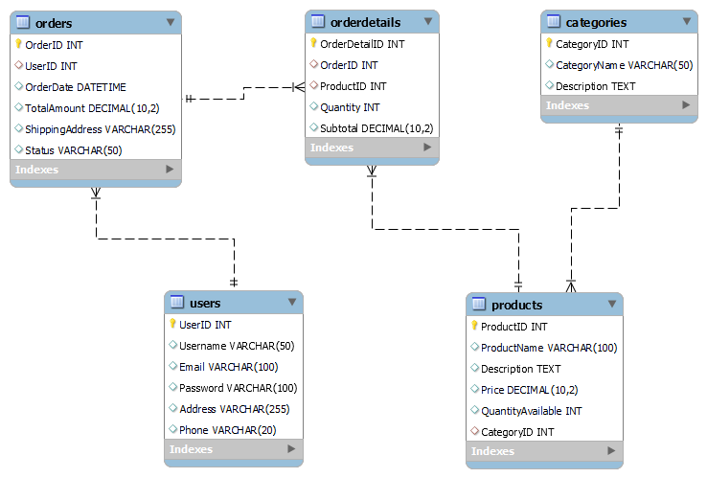

Relationships:

* Users have orders (One-to-Many Relationship: One user can have multiple orders).
* Orders contain order details (One-to-Many Relationship: One order can have multiple order details).
* Products fall under categories (One-to-Many Relationship: One category can have multiple products).